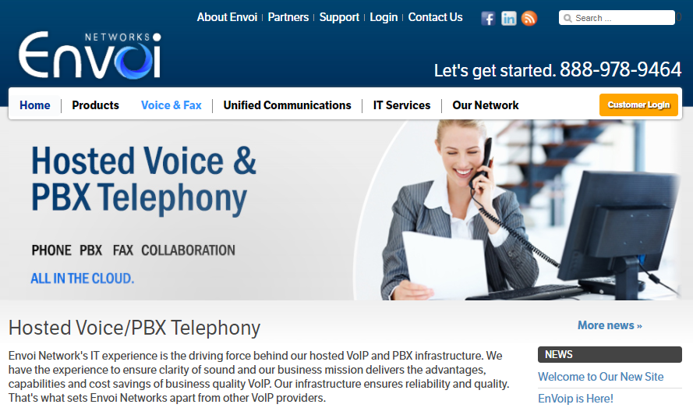

We like to take the middle section out where is has the “Why Choose a Hosted Solution with the Tabs and the paragraph below it and add the below text instead.

(I added the icons to break the monotony of all the wording but open to ideas as if it fits or not. I got the icons from: https://www.shutterstock.com/g/irina_sulima?searchterm=background+&search_source=base_gallery&language=en&sort=popular&safe=true )

We have been working very hard on our enterprise VoIP & PBX platform and we are happy to announce the arrival of our new EnVoip platform. We now offer an End-to-End managed solution that extends our Service Level Agreement (SLA) all the way to our customer’s premise and we can offer solutions that will guaranty our QoS (Quality of Service) and Uptime Guarantee up to 99.999%. We can also work with you to find the lowest priced Internet Connectivity available in your area with added redundancies such as a Business Continuity Plans and Disaster Recovery Solutions. So you no longer have to worry about downtime or service interruptions.

We are now offering our 2X promotion where we are giving our customers FREE Polycom VVX301 and VVX401 phone rentals and including ALL of our Premium Features in our plans! This means that all of our customers will receive:
FREE Polycom Phone Rental with Assurance & Advance Replacement: Included in our plans are the premium Polycom phones which are the market leader in VoIP phones. You get a choice of the VVX301 or the VVX401 phones based on the term you choose.
FREE Unlimited Minutes Calling: This includes calls to the US Lower 48 States, Puerto Rico and most of Canada
FREE No-Busy Phone Lines: This option allows you to have all the lines you need to make sure you and your customer never receive a busy tone and you can have extra lines to use with your free Conference Bridge and Call Center/Call Queue features.
FREE Ring-Anywhere Feature: You no longer have to be in the office to answer your phones. With Call-Anywhere, incoming calls can be answered on your desk phone, additional softphone or your alternate cell or landline phone. Once you answer form one device, the others will stop ringing. However, we don’t stop there, our system holds on to your call in case you need to record it or transfer it back from your cell phone to your desk phone or any other destination.
FREE DID/Phone Number per Extension: With each user extension, we give a free local US or Canada DID/Phone Number so each person can have their own direct number at no extra cost.
FREE IVR/Auto-Attendants: Program as many calling trees necessary to make sure your business runs efficiently. Set up an Office Hours, After Hours, Holidays and other informational IVR’s at no extra charge.
FREE Call Analytics: With this option, you can run reports and analyze them to make sure your business is running smoothly and how your calls are managed throughout the office. Advanced analytics options are also available for an additional low monthly cost.
FREE White Glove Support & Software Upgrades: Your organization will receive continued premium on-shore support of your hosted VoIP & PBX system. Our trained staff will immediately assist you by phone or through our email ticketing system. We will also train you and give you access to the EnVoip portal so you can make changes on your own. Our system is always being updated and improved and you will automatically receive our software updates.
FREE Operator/User Control Panel: You will have access to the EnVoip Control Panel that will allow you to see who is on the phone, transfer calls by dragging and dropping extensions, dial outside numbers, listen to messages and many other features.
FREE Conference Bridging: Each user will have their own conference bridge with no per-minute charging and advanced features.
FREE Call Center/Call Queues: Allows you to setup and manage Call Queues and Agents and the system will automatically place calls in a queue, enabling operators/agents to handle multiple incoming calls.
FREE Call Recording: Enterprise call recording services are available and can be set by extension, hunt groups or numbers. Recordings can be accessed through the EnVoip portal and recordings can be either downloaded for permanent storage or emailed automatically after each call.
FREE International Calling to 50 Countries: Aside from receiving very low International calling rates, you can make free calls to over 50 countries, which includes most landlines and some cellular services. Free countries include United Kingdom, Germany, France, China, Mexico, India, Brazil, Taiwan, South Africa and many others. Please refer to Envoi Networks’ Int’l rate deck for full details and to determine the Country and City codes of included routes.
We will be happy to discuss these options with you so contact us so we can offer you a No-Obligation quote and a Free Internet Connectivity survey for your area.

EnVoip™ Phone/PBX Features
In addition to the general advantages of a Hosted Cloud based system that include affordability, scalability, ease of use and mobility; our EnVoip Platform provides management tools that will help you run your business efficiently. Our Detailed Call Analytics allow you to evaluate and study your call volume so you can efficiently manage your calls using our Intelligent Call Routing features. We also deliver options such as Call Recording, Conference Bridging, Call Center/Call Queuing, Unlimited Telephone Lines and many other features, all at NO EXTRA COST! Please see EnVoip’s Enterprise Hosted PBX full feature list below:

Telephone Options
- 3 Way Calling
- Auto Attendant/IVR
- Call Center/Queuing
- Caller ID/CNAM
- Call Transfer
- Class of Service
- Click to Dial
- Control Panel
- Distinctive Ring
- E-911 Service
- Features Codes
- Holiday Settings
- Hunt Groups
- Intercom
- International Calling
- Music on Hold
- Name Directory
- Online Account Management
- Proactive Monitoring
- Screen Popup
- Sound File Imports
- Speed Dialing
- Time Groups
- Toll Free Numbers
- Voicemail
- Voicemail Indicator
- Voicemail to E-mail
- Web Portal Access

Call Management
- Anonymous Call Block
- Busy Phone Field
- Call Blocking
- Call Forwarding
- Call History
- Call Hunt Groups
- Call Monitoring
- Call Pattern
- Call Queues
- Call Que Status
- Call Recording
- Call Tracking
- Call Waiting
- Caller ID Block
- Caller Announcement

Business Features
- Announcement Hotline
- Auto Billing
- Auto Provisioning
- Bulk Dialing
- Call Center Functions
- Call History
- Call Monitoring
- Call Recording
- Conference Calling
- Conference Bridge
- Conference Invite
- Dial by Name Directory
- Enhanced 411 Listing
- Extension Dialing
- Fax to Email & to Fax Machine
- New Local DID
- New Toll Free DID
- Number Porting
- Online Accounting
- Overhead Paging
- Page Group
- Pickup Groups
- Receptionist Console
- Remote Access
- Simultaneous Ring
- SIP Trunking
- Time Route Calling
- Voicemail Distribution

Mobility
- Android/iOS App
- Boomerang Calling
- Cell to Phone Transfer
- Find-Me-Follow-Me
- Desktop Call Assistant
- Hoteling
- Outlook Integration
- Ring-Anywhere
- Softphones
- Virtual Numbers
- Virtual Telephones
- Web Faxing

Why Choose Envoi Networks
We understand there are many choices when it comes to VoIP Companies. Why choose Envoi Networks, here are a few reasons:
- We are not a white-label reseller like many companies out there. We own and operate our own VoIP platform and host it in our infrastructure. As a result, we can offer you a Service Level Agreement and an uptime guaranteed of up to 99.999%.
- We are a turn-key service provider. We project-manage every step of the process, from providing and configuring the hardware, assisting with your network setup, implementing your system, ensuring QoS (Quality of Service) and all the way to the training of your staff. And we don’t stop there, we continue to be there for you with our White-Glove Customer Support any time you need us.
- We are fair, reasonable and always deliver on our promises. We treat our clients right and that is why we have such a high customer retention rate.

